YOG Technical Design Document: Sailing | November 18  2008
This is the Technical Design Document for the Youth Olympic Games 2010 virtual world games. The game detailed within is Sailing. Written by Brandon Fam and Brian Young. |  | Copyright ©2008 Nanyang Polytechnic

Contents
Project Information 5
Introduction 5
What is Second Life? * 5
Objectives 6
Mission 6
Target Audience 6
Unique Selling Point 6
Platform Requirements 7
Game Play 8
Objectives 8
Game Flow 8
1. Choose Mode 9
a. Wacky 9
b. Realistic 9
2. Game Registration 9
3. Choose Boat 9
4. Board Boat 9
5. Race 9
6. Finish Race 9
7. End Race 9
8. Receive YOG Points 9
Registry 10
Registry Script 10
Boat Tracker 11
Game Types 12
Realistic 12
Wacky 14
Laser Sailboat Scripts 18
Laser Wacky Sailboat Scripts 20
Display Boat Scripts 22
Controls for Boats 23
UP key 23
Down Key 23
LEFT key 23
RIGHT key 23
PAGE UP key + UP or DOWN Key 23
PAGE DOWN key 23
Win/Lose Conditions 23
Scoring System 24
Scoreboard Scripts 24
Security System 26
Lifejacket 26
Lifejacket Shack 26
Floor Teleporter 27
Email and Registration System 28
Player Enquiry System 28
Other Scripts 29
Aesthetic Assets 30
Realistic 30
Fire Breathing Merlion 30
Funky Merlion 31
Display Ship 33
Glowing Feet 33
Feet Pad Script 33
Feet Root Script 33
Feet Glow Script 33
Wacky 34
Smiling Sun 34
Waves 35
Others 35
Music Player Script 35
Vinyl Disc 35
Technical Appendices 36
Channel Index 36
point_Listener 36
point_Activater 36
point_Reset 36
point_Data 36
Registry 36
Olympic_Bracelet 37
Boat_Channel 37
Sailing_Scoreboard_Realistic 37
Sailing_Scoreboard_Wacky 37
Wacky_Channel 37
Sax_Channel 38
Dialog_Channel 38
lifejacket_shack_channel 38
ReceptionChannel 38
ReceptionChannel 38
Email_Channel 38

Project Information

Introduction
This is a project endorsed by the Youth Olympic Games (YOG) Committee who will be handling the event in the year 2010 in Singapore. We have been tasked to create games based on actual games from the YOG in a virtual world. The virtual word we have chosen for our platform is Second Life.

What is Second Life? *
Second Life® is a 3-D virtual world created by its Residents. Since opening to the public in 2003, it has grown explosively and today is inhabited by millions of Residents from around the globe.
- From the moment you enter the World you'll discover a vast digital continent, teeming with people, entertainment, experiences and opportunity. Once you've explored a bit, perhaps you'll find a perfect parcel of land to build your house or business.
- You'll also be surrounded by the Creations of your fellow Residents. Because Residents retain intellectual property rights in their digital creations, they can buy, sell and trade with other Residents.
- The Marketplace currently supports millions of US dollars in monthly transactions. This commerce is handled with the inworld unit of trade, the Linden™ dollar, which can be converted to US dollars at several thriving online Linden dollar exchanges.

*taken from http://secondlife.com/whatis/

Objectives

Mission
For this project, we have been divided into 2 teams, YOG1 and YOG2. YOG1 has been tasked to create two games: Fencing and Sailing. YOG2 has been tasked to create a different set of games: BMX bicycle race and equestrian. Both teams have to create a wacky and realistic versions of their respective games. The overall aim of this project is to promote the Youth Olympic Games in Singapore both locally and internationally. And also it is to promote an active lifestyle amongst the youths around the world with sports and other major activities.

Target Audience
This project would be specifically targeted towards youths between 13-18 years old, who do not lead active lifestyles and need to be educated about the variety of sports that the world offers.

Unique Selling Point
Our games offer a very good retrospective of the Olympic Games and how they function with respect to their sports. They also emulate the actual game events that take place and promote the Olympic spirit. Lastly, we offer a wacky gaming alternative that will be much more familiar to those who play computer games often.

Platform Requirements
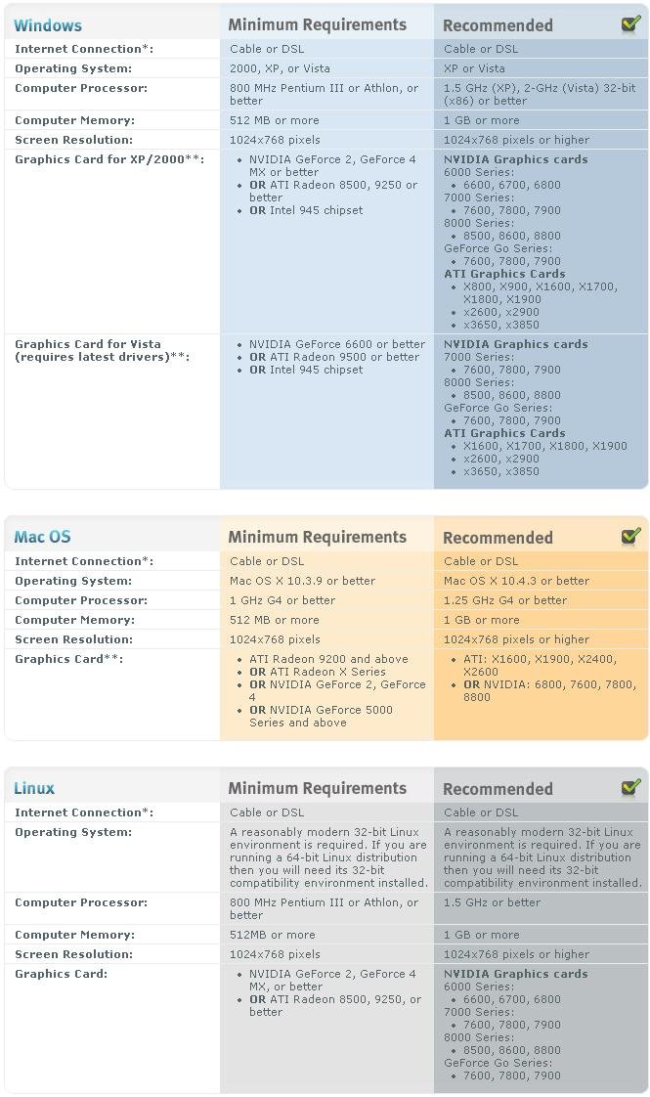

Game Play

Objectives
Our objective is to create a game of sailing that emulates the real life sailing in the Youth Olympics as much as possible in Second Life. At the same time, our objective is to ensure that the player is having fun without making the game too realistic, and thus frustrating.

Game Flow
Before playing the game, players need to register themselves for the games in the registration booth at the starting area of our Second Life Island. Then, they can teleport to the Sailing Port Arena, where players can compete in a game of sailing.
At the Sailing Port, they will first have to get a free lifejacket at the Lifejacket Shack. The Lifejacket acts as a security device for Sailors. Below is a diagram concerning Game Flow.
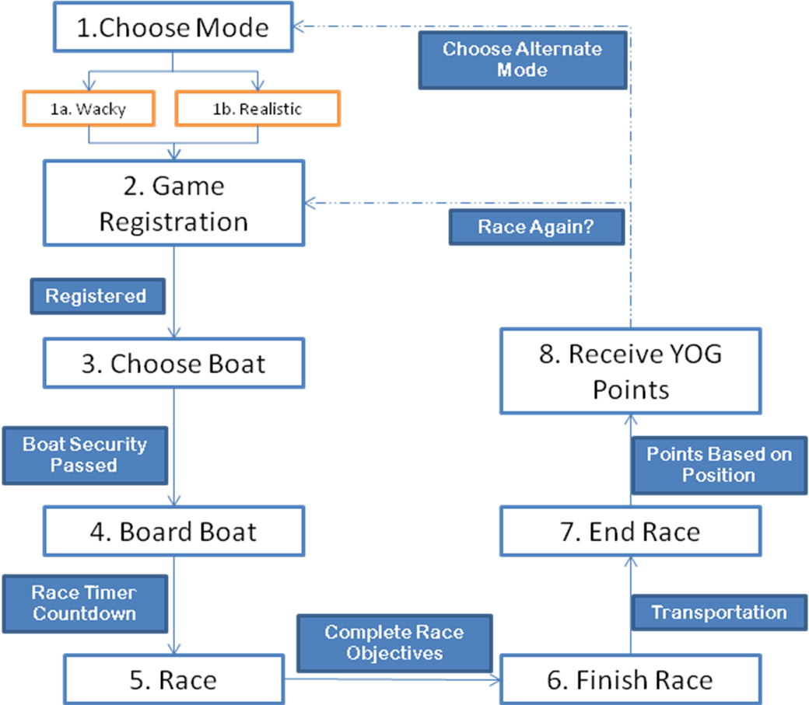

Choose Mode
Before starting a race, the player(s) can choose a game mode, realistic or wacky. The 2 gameplay types are unique, and with a press of a button, can alternate.

Wacky
Player(s) choose Wacky Mode.

Realistic
Player(s) choose Realistic Mode.

Game Registration
The player(s) register for the race by walking through a transparent plane which acts as a gate. It is phantom when open, meaning that avatars can pass through it. However, it is solid when closed. The countdown begins for the race to start.

Choose Boat
The player is then presented with a pop-up menu, where they have a choice in boat design. Once they have chosen a boat, the boat is then generated beside them on the port, with their name on it.

Board Boat
Players can only board the boat they have chosen, which has their name on it. If they attempt to board another player’s boat, they will be unseated from them and translated back to shore by their lifejacket.

Race
After the countdown goes to zero, the race starts. Players must race from point to point to progress in the race, until they reach the finish line.

Finish Race
When a player finishes a race, he crosses the finish line. He is then translated back to the port area via the security lifejacket.

End Race
At the end of a race, all players have crossed the finish line. Their positions and timings will be reflected on a scoreboard for their respective race category.

Receive YOG Points
At this point, based on their positioning, players earn their YOG points based on their race position. To earn more points, they can choose to race again, or race on an alternative race mode.

Registry
The registry is the gate that players walk through in order to register for a race.

Registry Script

Description
The registry communicates with the points and boat tracker about the race. It allows the player to choose a boat of their preference by opening a dialog box for the player.

Channels Used
- point_Listener
  - listen to information about points
- point_Activater
  - Communication for activating points.
- point_Reset
  - Communication for resetting points.
- Registry
  - Sends messages from it, like starting or ending race registration.
- Boat_Channel
  - Sending information to boats, like unsitting an player and disqualifying him or her.
- Wacky_Channel
  - Sends information whether to show wacky assets or not.
- Dialog_Channel
  - Sends and receives information about player dialog box choices.

Boat Tracker
The boat tracker keeps track of all participants in a race. It takes note of what points or turns a participant has passed, when he has finished a race and at what position he finished. It also takes note of players that have been disqualified, and removes them from the player list.

Boat Tracker Script

Description
The boat tracker script is the cornerstone for race operation. It communicates with many different aspects of the race, such as the racing points, the music player, the registry, and the scoreboard. It does calculations regarding race results and sends them to the scoreboard, depending on the mode.

Channels Used
- point_Listener
  - Receiving information about points, such as boat collisions.
- point_Activater
  - Communication about activating race points.
- point_Reset
  - Communication about resetting race points.
- point_Data
  - Receives information about points, such as the number of turns required.
- Registry
  - Communication to the registry about the start and end of a race.
- Olympic_Bracelet
  - Communication about sending a disqualified player to a certain area.
- Boat_Channel

- Sailing_Scoreboard_Realistic OR Sailing_Scoreboard_Wacky
  - At the end of a race depending on the mode, the results of the race are sent to the scoreboard.
- Wacky_Channel
  - Receives information as to whether it is realistic or wacky mode now.
- Sax_Channel
  - Communication about current song to be played.

Game Types
We have implemented 2 race modes for the player to enjoy. They are Realistic, and Wacky.

Realistic
In realistic sailing, players pilot a boat which moves according to the wind and the direction of its sail. Based on the boats orientation and desired destination, the player must rotate his or her sail to keep his or her boat moving. It is important to pay attention to the wind direction, which is indicated by a stream of particles emerging from the sail mast. An idea of various wind types is shown in the diagram below.
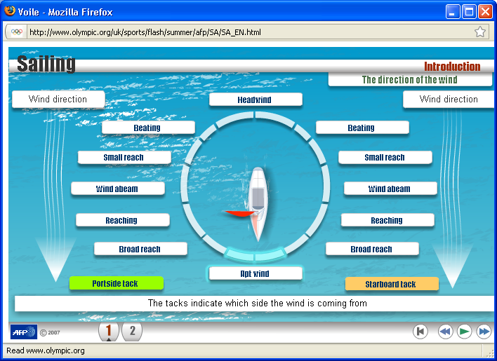

The players must navigate around an ocean with buoys, and travel around them in a specific order. This makes the course of our game. A map of an example course is shown below.
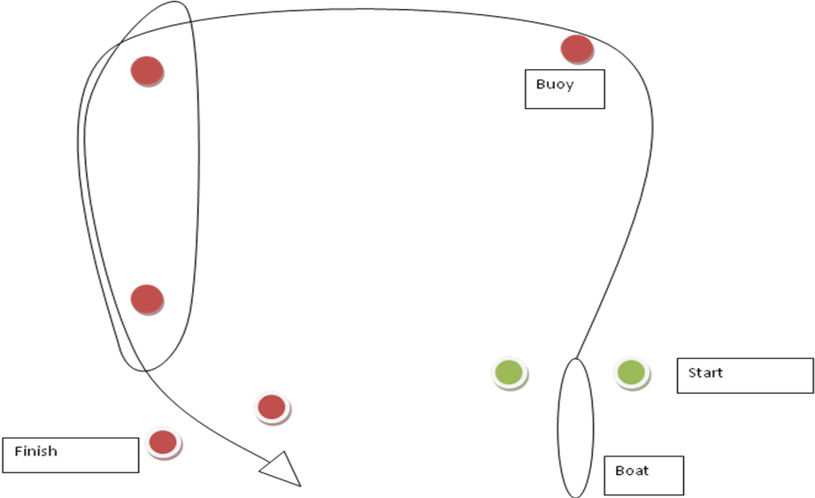
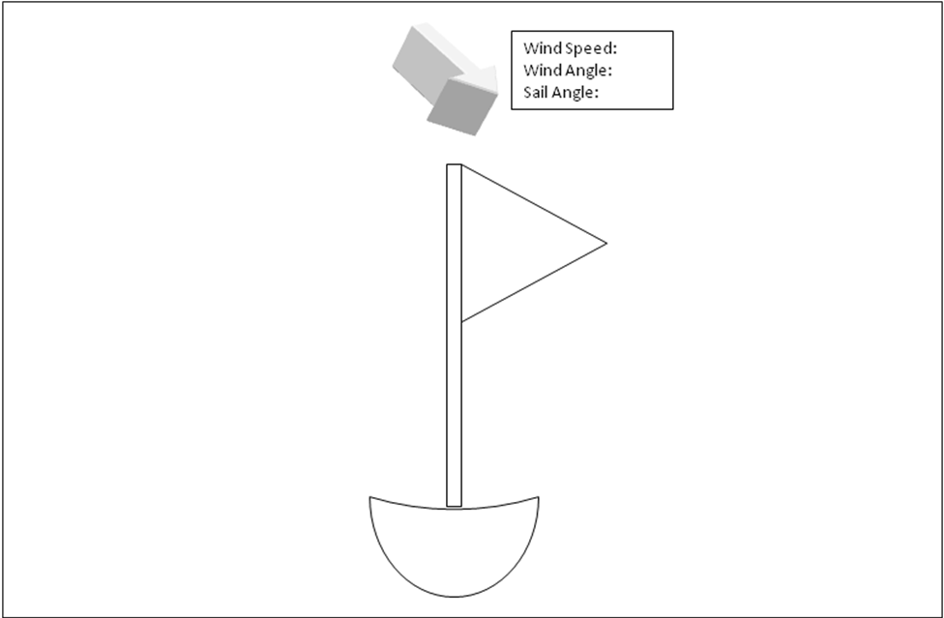
As the player travels, he also plays attention to his graphical user interface, which consists of floating text above the boat describing various parameters. An example is shown in the below diagram.

Wacky
In wacky mode, players are less reliant on the wind to pull their boats, as the wind strength for wacky mode has been increased to be twice as strong as that in realistic mode. So, they will travel faster than in realistic mode. The wacky boats are equipped with thrusters, which give them speed boosts whenever their boats touch speed pads.

Oil Slicks
The oil slicks are obstacles that boats have to travel around. If boats touch them, they will slip and spin.

Slip Pad Script

Description
The slip pad script is located in the oil slick, where if a boat touches the primitive, the boat spins. This only affects wacky boats. This script communicates with the boat that it has collided with, and requests that the boat spins in place. If it is not wacky mode, the Wacky Mode Button tells the primitive to rise in the air and go transparent. Otherwise, the primitive will come down and be active for wacky racing.

Channels Used
- Boat_Channel
  - Communicate with boat about slipping.
- Wacky_Channel
  - Receive messages about toggling wacky mode.

Barriers
Barriers guide boats along the course, making them turn in the right direction. The barriers cause the boat to slow down, and come to a complete stop if the boats hit them head on.

Barrier Script

Description
If it is not wacky mode, the Wacky Mode Button tells the primitive to rise in the air and go transparent. Otherwise, the primitive will come down and be active for wacky racing.

Channels Used
- Boat_Channel
  - Communicate with boat about slipping.
- Wacky_Channel
  - Receive messages about toggling wacky mode.

Speed Boosts
Boats can get a speed boost by touching speed boost pads. Their existing speed is multiplied by a factor, increasing their forward velocity.

Boost Glow

Description
This script takes linked messages from the boost root, which tell its primitive when to glow and not to.

Channels Used
None.

Boost Pad

Description
If it is not wacky mode, the Wacky Mode Button tells the primitive to rise in the air and go transparent. Otherwise, the primitive will come down and be active for wacky racing. The boost pad script is located in the root, where if a boat touches the primitive or its children, the boat gets a speed boost. This only affects wacky boats. This script communicates with the boat that it has collided with, and requests that the boat gets a speed boost.

Channels Used
- Wacky_Channel
  - Receive messages about toggling wacky mode.
- Boat_Channel
  - Communicate with boat about speed boost.

Boost Root

Description
This script controls the glowing sequence of boost strips by a timer. It is located in the root and children of boost pads.

Channels Used
None.

Ramp
Boats can climb on ramps and make jumps. The ramps do cause the boats to slow down due to the effects of friction.

Ramp Script

Description
If it is not wacky mode, the Wacky Mode Button tells the primitive to rise in the air and go transparent. Otherwise, the primitive will come down and be active for wacky racing.

Channels Used
- Wacky_Channel
  - Receive messages about toggling wacky mode.

Check Points
Boats still have to touch check points in order to progressively finish the race.

Points Script

Description
This script holds information about the point number, and responds when the boat tracker wants to know how many points are available prior to a race. When a boat collides with it, it sends a message to the boat tracker informing it about the collision.

Channels Used
- point_Listener
  - sending information
- point_Activater
  - Receiving message about activating point, which makes the primitive it is in phantom.
- point_Reset
  - Receiving message about resetting point, which makes the primitive it is in solid.
- point_Data
  - sending and receiving data about the point.

Turns Script

Description
This script holds information about the turns number, the number of turns required to pass through, and responds when the boat tracker wants to know how many turns are available prior to a race. When a boat collides with it, it sends a message to the boat tracker informing it about the collision.

Channels Used
- point_Listener
  - Sending information.
- point_Activater
  - Receiving message about activating turn, which makes the primitive it is in phantom.
- point_Reset
  - Receiving message about resetting turn, which makes the primitive it is in solid.
- point_Data
  - Sending and receiving data about the turn.

Starting Line Script

Description
This script holds information about the starting line as a point. When a boat collides with it, it sends a message to the boat tracker informing it about the collision.

Channels Used
- point_Listener
  - Sending information.
- point_Activater
  - Receiving message about activating turn, which makes the primitive it is in phantom.
- point_Reset
  - Receiving message about resetting turn, which makes the primitive it is in solid.
- point_Data
  - Sending and receiving data about the turn.

Finish Line Script

Description
This script holds information about the finish line as a point. When a boat collides with it, it sends a message to the boat tracker informing it about the collision.

Channels Used
- point_Listener
  - Sending information.
- point_Activater
  - Receiving message about activating turn, which makes the primitive it is in phantom.
- point_Reset
  - Receiving message about resetting turn, which makes the primitive it is in solid.
- point_Data
  - Sending and receiving data about the turn.

Buoys Scripting
The buoys are used to guide the boats during the race, and they prevent boats from veering too far off course.

Description
This script is used to control the buoy’s fixed and unfixed position. To set the buoy in a fixed position, the owner only has to click on it.

Channels Used
None

Laser Sailboat Scripts

Controls Script

Description
This script handles boat controls and applies speed, rotation to the boat. It also tracks the player and has an on board security system checking if the boat belongs to the player. It is located in the root primitive.

Channels Used
- Olympic_Bracelet
  - Telling the player with lifejacket to teleport back to shore, if he stood up
- Boat_Channel
  - Communication between boat tracker, registry and boat, such as teleporting the avatar or setting the boat name
- point_Data
  - communicate that player has been disqualified
- Registry
  - Receiving signal to end race and for boat to destroy itself

Name Script

Description
It receives linked messages from Control Script to change boat label name. It is located in the root primitive.

Channels Used
None.

Sail Holder Script

Description
It rotates the cylinder beneath the sail on a sailboat. It is located in the sailholder primitive.

Channels Used
None.

SailRot Script

Description
It is used to rotate the sail above the boat, as well as calculate boat velocity based on the sails angle and the boat’s orientation to the wind. It is located in the sail primitive.

Channels Used
None.

windindicator Script

Description
It is used to receive information about wind direction, and display it as a particle stream emitting from the windindicator primitive. It is located in windindicator primitive.

Channels Used
None.

Splash Script

Description
It receives information about boat velocity from the SailRot Script and generates particles resembling water splash based on that velocity. It is located in the splash primitives.

Channels Used
None.

Laser Wacky Sailboat Scripts

Movement Script

Description
This script controls movement of the boat in terms of speed and velocity. It also toggles Speed Boost and Sliding.

Channels Used
- Boat_Channel
  - Receiving information about toggling Speed Boost and Sliding.

Sail Control Script

Description
This script controls the rotation of the boat sail.

Channels Used
- Olympic_Bracelet
  - Telling the player with lifejacket to teleport back to shore, if he stood up
- Boat_Channel
  - Communication between boat tracker, registry and boat, such as teleporting the avatar or setting the boat name
- point_Data
  - communicate that player has been disqualified
- Registry
  - Receiving signal to end race and for boat to destroy itself

Turning & Camera Script

Description
This script controls the camera and turning of the boat through player input.

Channels Used
None.

Name Script

Description
It receives linked messages from Control Script to change boat label name. It is located in the root primitive.

Channels Used
None.

Sail Holder Script

Description
It rotates the cylinder beneath the sail on a sailboat. It is located in the sailholder primitive.

Channels Used
None.

SailRot Script

Description
It is used to rotate the sail above the boat, as well as calculate boat velocity based on the sails angle and the boat’s orientation to the wind. It is located in the sail primitive.

Channels Used
None.

windindicator Script

Description
It is used to receive information about wind direction, and display it as a particle stream emitting from the windindicator primitive. It is located in windindicator primitive.

Channels Used
None.

Splash Script

Description
It receives information about boat velocity from the SailRot Script and generates particles resembling water splash based on that velocity. Located in the splash primitives.

Channels Used
None.

Lion Fire Script

Description
This script controls particle emissions that resemble flames from the boat. It is based on the script used to control the fire breathing merlion’s fire. There may be several of these scripts depending on the number of particle emitters on each boat.

Channels Used
None.

Lion Base Fire base Script

Description
This script controls particle emissions that resemble flame cores from the boat. It is based on the script used to control the fire breathing merlion’s fire. There may be several of these scripts depending on the number of particle emitters on each boat.

Channels Used
None.

Display Boat Scripts

Display Boat Script

Description
This script receives messages from the Registry which label the display boat for a specific boat (Realistic or Wacky). It is meant to help player make decisions regarding boat design. The script is located in the root of a display boat. It also receives messages from the registry to destroy itself.

Channels Used
- Registry
  - Receives signal to change boat label.

Name Script

Description
This script receives linked messages from the display boat script, and labels the boat by sending linked messages to other primitives of the boat which are labels.

Channels Used
None.

Controls for Boats
UP key
Rotate sail clockwise.
Down Key
Rotate sail anticlockwise.
LEFT key
Turn rudder to the left.
RIGHT key
Turn rudder to the right.
PAGE UP key + UP or DOWN Key
Rotate sail in large increments.
PAGE DOWN key
Change camera angle.

Win/Lose Conditions
The player has to score higher positions in the race to earn more points. The least points are given to those lower in the racing ranks. The player will be disqualified and translated back to shore if he stands up from his boat. This is to prevent cheating in Second Life as players can jump onto other boats, or make their boats come to a complete stop when standing up, which would be helpful if they needed to do tight turns.

Scoring System
The scoring system for sailing (both realistic and wacky) is based on that in real life. Your overall ranking among other players is calculated based on the total points earned after a series of races. The top scorers have the highest number of points on a leader board. However, each players points degrade over periods of time, so the points earned in the last period will be worth less than the points earned in the current period. An example is shown in the table below.
Name | Current Segment (1.0) | Segment 1  (0.5) | Segment 2  (0.3) | Segment 3  (0.1) | Total points
Player | 30 | 50 | 70 | 20 | 48
In the table, the player has earned 30 points from races in the current period. In the earlier periods, or segments, they are worth less, and contribute less to the total points a player is worth in the score board. For example, in segment 1, the score that the player earned is only worth 25 points, because his score is multiplied by 0.5 for that segment.
In race scoring, the higher your position, the more points you earn based on the number of racers, an example is shown in the table below.
Name | Position | Points | Time
Player 1 | 1st | 3 | 3m0s
Player 2 | 2nd | 2 | 5m0s
Player 3 | 3rd | 1 | 7m0s
In the table, player 1 is in 1st position with 3 points earned, because there are 3 racers in total. Player 3 on the other hand only earns 1 point because he is last in the race with the 2 other racers.

Scoreboard Scripts
There are 2 different scoreboards; one for realistic and one for wacky. The scripts contained within each are identical, except for the channel used to communicate with them. The Realistic scoreboard uses the Sailing_Scoreboard_Realistic channel, and the Wacky scoreboard uses the Sailing_Scoreboard_Wacky channel.

Name & Time Display Script

Description
This script receives messages from the Boat Tracker, which contains information about the previous race, the player positions, and their times. This script calculates the total points earned cumulatively for each player, and sends messages to display it as an overall ranking list on the board.

Channels Used
- Sailing_Scoreboard_Realistic OR Sailing_Scoreboard_Wacky
  - Communicate player positions and timings

Name & Time Display (#num) Script

Description
This script receives linked messages from Name & Time Display original script, which contains information about data to display. This script is in a separate linked set because with too many links, the returns for text rendering will diminish.

Channels Used
- Sailing_Scoreboard_Realistic OR Sailing_Scoreboard_Wacky
  - Receive information about data to render in rows and columns

Position Display

Description
This script receives linked messages from Name & Time Display original script, which contains information about data to display. This script is in a separate linked set because with too many links, the returns for text rendering will diminish. The data here is position and column category names.

Channels Used
- Sailing_Scoreboard_Realistic OR Sailing_Scoreboard_Wacky
  - Receive information about data to render in rows and columns

Security System
In Sailing, a lifejacket system is implemented to control the player’s movement. It is designed to keep the player from intruding the game, and to facilitate movement within the start and end of a race.

Lifejacket

Olympic Bracelet Script

Description
The lifejacket controls player movement, and is required during races.

Channels Used
- Olympic_Bracelet
  - Communication to transport player.

Lifejacket Shack
The lifejacket shack is where players retrieve their lifejackets.

Lifejacket Giver Script

Description
This script is used to give out lifejackets to players who click on the primitive that contains it.

Channels Used
None

Bob the Robot Script

Description
Bob is a robot that explains to the player that it is necessary to wear a lifejacket. He checks if the player is currently wearing one, and will ask the player to wear one if he is not. If the player is wearing a lifejacket, he thanks the player.

Channels Used
- lifejacket_shack_channel
  - receive information that the player has taken a lifejacket
- Olympic_Bracelet
  - Checking if the player is wearing a lifejacket.

Floor Teleporter

Floor Teleport Script

Description
The teleporter is a set of primitives placed underwater to control player movement, should players fall in. The teleporter will ensure that during a race, all avatars are pushed underwater when falling into the water so as to not interfere with the race. Outside a race, avatars will be translated back to shore if they are wearing a lifejacket.

Channels Used
- Olympic_Bracelet
  - Used to communicate a teleportation location for players.
- Registry
  - Used to receive data about current Mode, Wacky or Realistic.

Email and Registration System
Registration by the player is done by speaking in a certain channel and saying your email address.

Client Sending Script

Description
The client sending script provides an interface to the player in registration, and tracking of YOG Points. The YOG points can be used to purchase trials and courses in the YOG sports.

Channels Used
- Email_Channel
  - The channel the player speaks in, in order to register.
- ComDialog_Channel
  - The channel that dialog boxes use for player choices.

Player Enquiry System
The player can ask Pablo the robot about basic information on the island, like navigation, YOG Points and registration

Pablo the Robot Script

Description
Pablo is a robot that explains to the player about the Youth Olympic Games in Second Life. This script is located in the root of Pablo’s head.

Channels Used
- ReceptionChannel
  - The channel that the player speaks in to ask Pablo questions.

Other Scripts

Main Script (10)

Description
This script is borrowed from http://wiki.secondlife.com/wiki/XyzzyText. It does the labeling of certain primitives with xyzzytext-0-0, with the digits denoting an id.

Channels Used
None.

Slave Script (10)

Description
This script helps the Main script by increasing the rendering speed for label text. With more of these scripts running in the same primitive as the main script, the faster the rendering. However, too many will cause diminishing returns.

Channels Used
None.

Aesthetic Assets

Realistic
These assets provide interactivity to the player, as well as make the environments much more interesting to look at. These assets are prominent in realistic mode. Below is a list of the assets, as well as details about the scripts they run.

Fire Breathing Merlion
This merlion spits water when in realistic mode, and fire in wacky mode. In wacky mode, it has glowing eyes and words appear above it, glowing in sequence.

Firebreath script
Description
This script causes the prim it is in to emit particles. For the Fire Breathing merlion, it emits water particles when in Realistic Mode, and Fire particles in wacky mode. It receives signals from the Wacky Mode Button about the current race mode. It is located in the root of the firebreath primitive.
Channels Used
- Wacky_Channel
  - Communication with the Wacky Mode Button at the port to alternate between realistic and wacky mode.

Lion base fire script
Description
This script causes the prim it is in to emit particles. For the Fire Breathing merlion, it emits water particles when in Realistic Mode, and Fire particles in wacky mode. It receives signals from the Wacky Mode Button about the current race mode. It is located in the child of the firebreath primitive.

Channels Used
- Wacky_Channel
  - Communication with the Wacky Mode Button at the port to alternate between realistic and wacky mode.

Eyes script
Description
This script causes the prim it is in to glow in wacky mode, and not glow in realistic mode. This script is located in the eyes of the merlion.

Channels Used
- Wacky_Channel
  - Communication with the Wacky Mode Button at the port to alternate between realistic and wacky mode.

RAWR Script
Description
This script controls the glowing order of letters in the RAWR Logo. It is located in the root of R of RAWR. If it is wacky mode, the glowing sequence will begin. If not, the whole of RAWR will be transparent, unseen by the player.
Channels Used
- Wacky_Channel
  - To know if it is currently wacky or realistic mode.

Letter Script
Description
This script receives signals from the RAWR script as to whether it should cause the prim it is in to glow or not.
Channels Used
- Wacky_Channel
  - To know if it is currently wacky or realistic mode.

Funky Merlion
The Funky Merlion plays music, and when in wacky mode, with a stylish saxophone.

Firebreath script
Description
This script causes the prim it is in to emit particles. For the Fire Breathing merlion, it emits water particles when in Realistic Mode, and no particles in wacky mode. It receives signals from the Wacky Mode Button about the current race mode. It is located in the root of the firebreath primitive.
Channels Used
- Wacky_Channel
  - Communication with the Wacky Mode Button at the port to alternate between realistic and wacky mode.

Lion base fire script
Description
This script causes the prim it is in to emit particles. For the Fire Breathing merlion, it emits water particles when in Realistic Mode, and no particles in wacky mode. It receives signals from the Wacky Mode Button about the current race mode. It is located in the child of the firebreath primitive.

Channels Used
- Wacky_Channel
  - Communication with the Wacky Mode Button at the port to alternate between realistic and wacky mode.

Eyes script
Description
This script causes the prim it is in to glow in wacky mode, and not glow in realistic mode. This script is located in the eyes of the merlion.

Channels Used
- Wacky_Channel
  - Communication with the Wacky Mode Button at the port to alternate between realistic and wacky mode.

Sax Sound
Description
This script enables sound playback in the saxophone. Based on the current mode or race period, the boat tracker communicates with this script to play requested sounds. This script is located in the root of the saxophone.
Channels Used
- Sax_Channel
  - Communication about song choice and selection.

Sax Glow
Description
This script causes parts of the saxophone to glow based on communication with the Wacky Mode Button. This script is located in the root and children of the saxophone.
Channels Used
- Wacky_Channel
  - Communication with the Wacky Mode Button at the port to alternate between realistic and wacky mode. If it is wacky mode, the saxophone part will glow. If not, the saxophone will become transparent.

Note Scripts
Description
These scripts control particle emission of musical notes from the saxophone bell. If in wacky mode, it emits the musical note particles.
Channels Used
- Wacky_Channel
  - Communication with the Wacky Mode Button at the port to alternate between realistic and wacky mode. If it is wacky mode, the note particles will stream out of the bell of the saxophone. If not, the particles will stop emitting.

Display Ship
The Display Ships are 2d billboard ships in the background. They are of carrier ships that are a common sight along Singapore’s shores.

DisplayShip Script
Description
This script causes the ship to be transparent in wacky mode, and opaque in realistic mode. This script is located in the root of the ship primitives.

Channels Used
- Wacky_Channel
  - Communication with the Wacky Mode Button at the port to alternate between realistic and wacky mode.

Glowing Feet
The glowing feet are meant to guide the player towards areas of interest, like the sailing lounge area, where they can learn about how to sail and the history of sailing. They glow in sequence and guide towards a path.

Feet Pad Script
Description
The feet pad script helps to reset the feet glowing sequence.

Channels Used
None.

Feet Root Script
Description
This script controls the glowing sequence of feet by a timer.

Channels Used
None.

Feet Glow Script
Description
This script controls the toggling of glowing based on messages received from the Feet Root Script.

Channels Used
None.

Wacky

Smiling Sun

Sun Glow Script
Description
The sun glow script is based on the Boost Glow Script. Please refer to that for further details. It is located in the root and children of the sun.

Channels Used
Please refer to Boost Glow Script for further details.

Sun Hide Script
Description
The sun hide script is based on the barrier Script. Please refer to that for further details. This is located in the root of the primitives.

Channels Used
Please refer to barrier Script for further details.

Sun Root Script
Description
The sun root script is based on the Boost Root Script. Please refer to that for further details. This is located in the root of the primitives.

Channels Used
Please refer to Boost Root Script for further details.

Waves

Sun Glow Script
Description
The sun glow script is based on the Boost Glow Script. Please refer to that for further details. It is located in the root and children of the sun.

Channels Used
Please refer to Boost Glow Script for further details.

Waves Script
Description
The sun hide script is based on the barrier Script. Please refer to that for further details. This is located in the root of the primitives.

Channels Used
Please refer to barrier Script for further details.

Boost Root
Description
This is the Boost Root Script. Please refer to that for further details. This is located in the root of the primitives.

Channels Used
Please refer to Boost Root Script for further details.

Others

Music Player Script
Description
The music player is a jukebox that plays music. To swap tracks, just click it. The script is located in the root of music player.

Channels Used
None.

Vinyl Disc
Description
The vinyl disc spins when playing music, and can spin at specified rates.

Channels Used
None.

Technical Appendices

Channel Index

point_Listener

Channel Number
-300

Description
This channel is used to communicate with points and turns to learn of their order and whether they are part of a race.

point_Activater

Channel Number
-301

Description
This channel is used to activate points and turns in the arena.

point_Reset

Channel Number
-302

Description
This channel is used to reset points and turns in the arena.

point_Data

Channel Number
-303

Description
This channel is used to send and receive specific data about points and turns in the sailing arena.

Registry

Channel Number
-304

Description
This channel is used to communicate to the registry.

Olympic_Bracelet

Channel Number
-305

Description
This channel is used to communicate with Lifejacket to translate player, and to learn if player has lifejacket attached.

Boat_Channel

Channel Number
-306

Description
This channel is used to communicate with the boats in sailing.

Sailing_Scoreboard_Realistic

Channel Number
-307

Description
This channel is used to communicate with the realistic sailing scoreboard.

Sailing_Scoreboard_Wacky

Channel Number
-308

Description
This channel is used to communicate with the wacky sailing scoreboard.

Wacky_Channel

Channel Number
-309

Description
This channel is used to communicate information about wacky features in wacky boats, such as togging speed boost and sliding.

Sax_Channel

Channel Number
-310

Description
This channel is used to communicate with the Merlion Saxophone which plays music.

Dialog_Channel

Channel Number
-311

Description
This channel is used to communicate information about the boat selection from the registry.

lifejacket_shack_channel

Channel Number
-312

Description
This channel is used to communicate information to the Lifejacket Shack robot.

ReceptionChannel

Channel Number
1234

Description
This channel is used to communicate information to the reception robot.

ReceptionChannel

Channel Number
1234

Description
This channel is used to communicate information to the reception robot.

Email_Channel

Channel Number
4321

Description
This channel is used to communicate information to the computer.

